Recon Account Number Error
The following recon account number error has been observed while creating customer master in S4 HANA QA.
ZREM , ZNOT , ZSHP doesn't have company code data where recon acc number exist . Recon acc field was also not given in the template that we have sent .
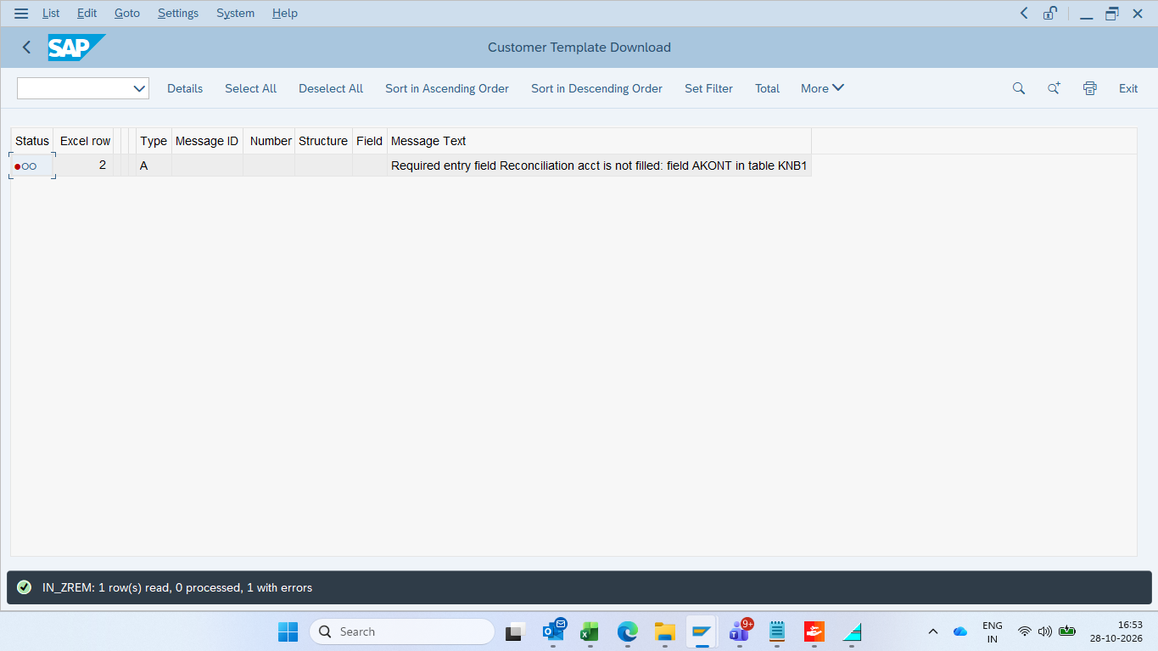
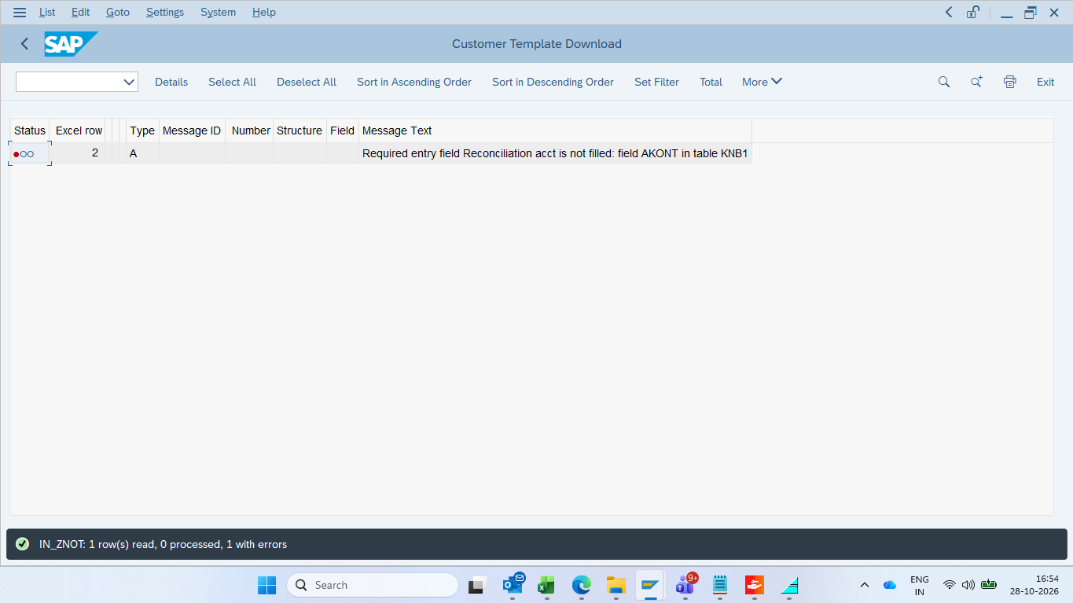
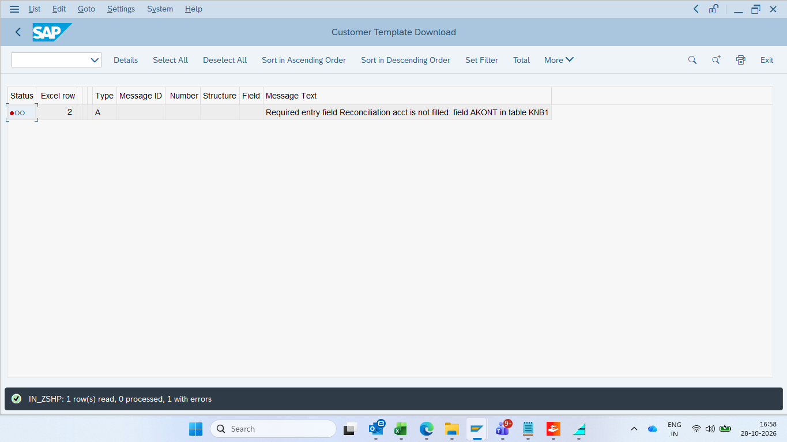

CIN Tab Missing
CIN tab is not available in S4 HANA QA . Attaching a screenshot of CIN tab from ECC production server for reference .
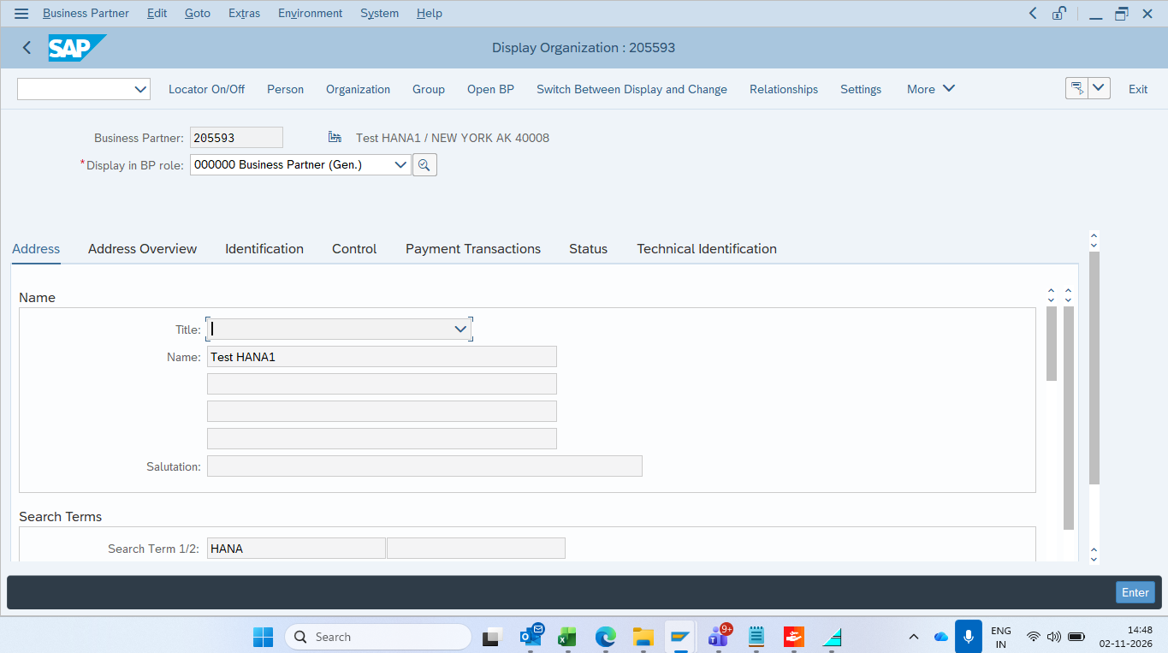
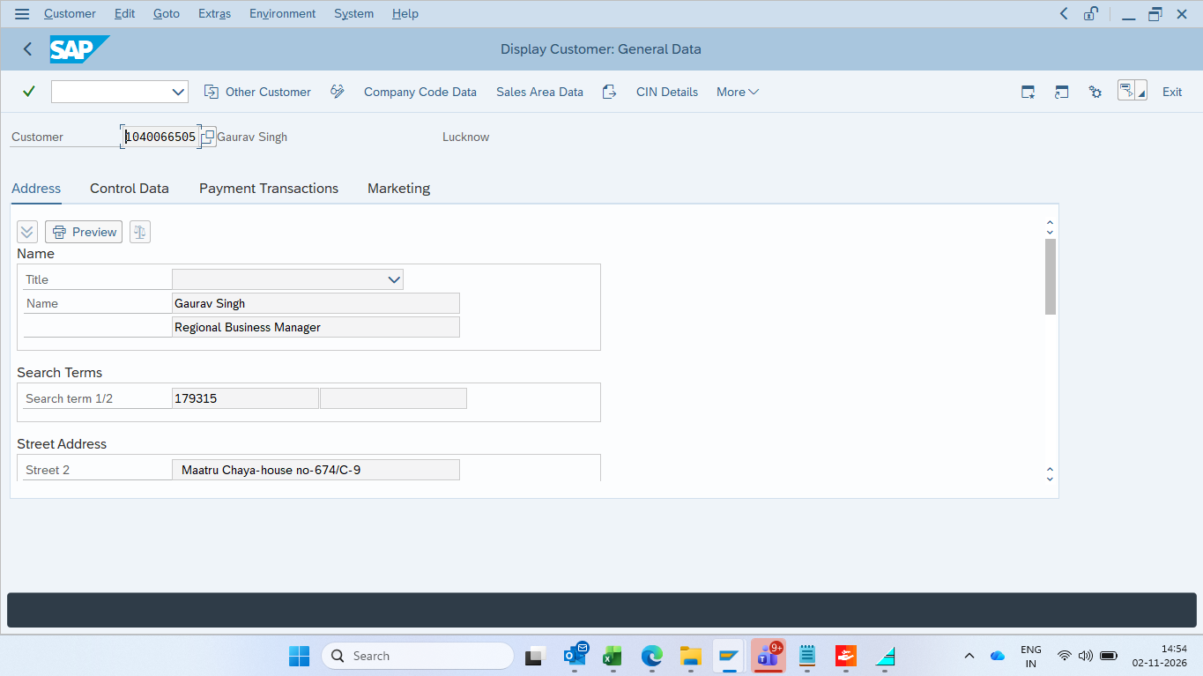
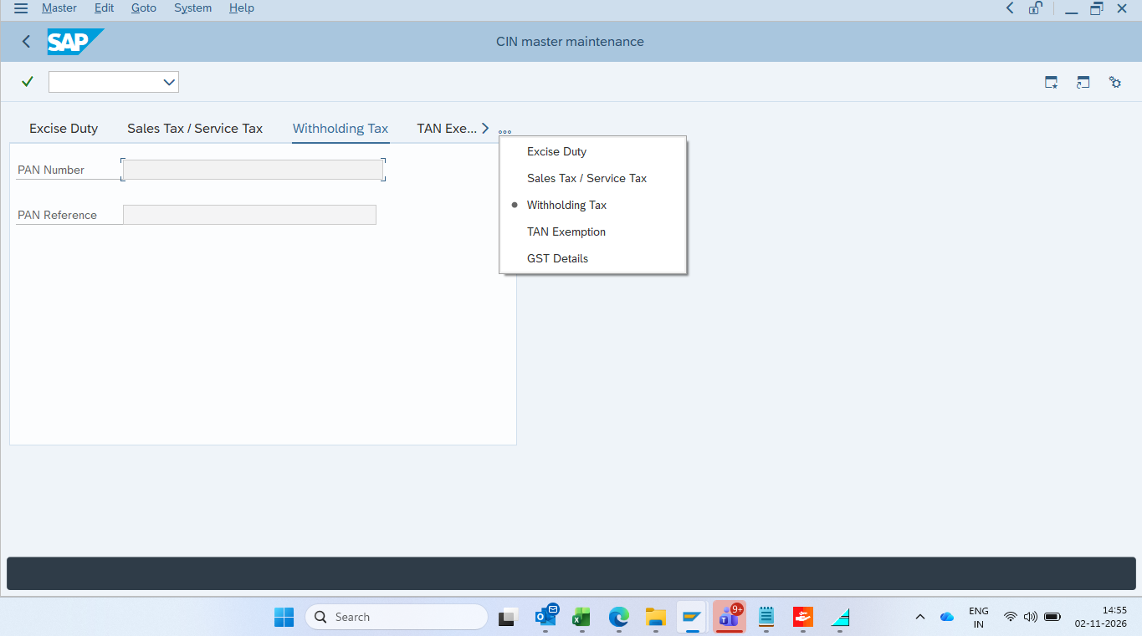

Customer Extension Error
The below error was encountered during customer extension , all these fields such as Reconciliation Account Number , sort key , incoterms are not available in the provided template which is generated using ZBP_CREATE_CUST.
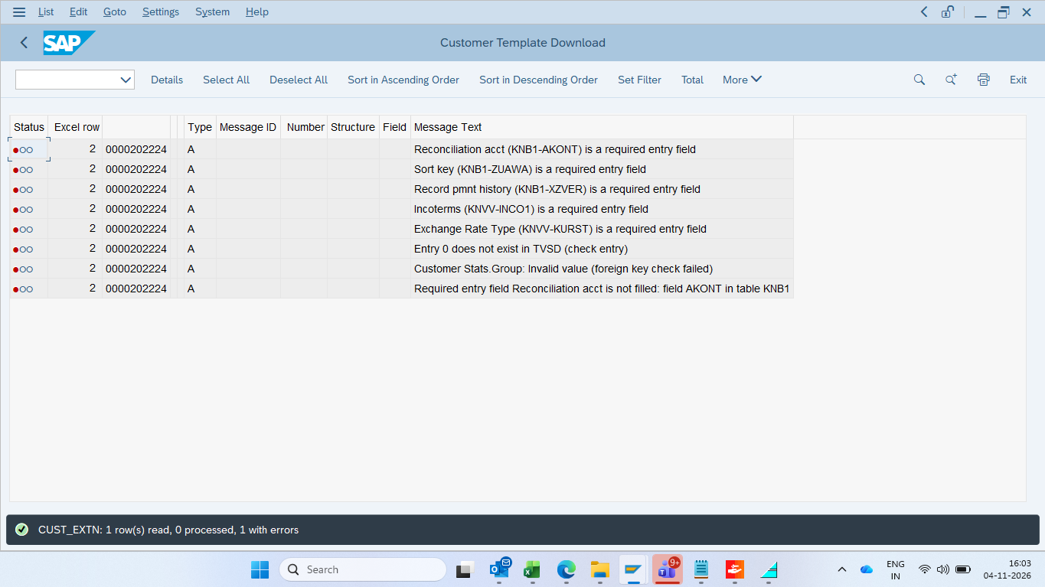

Unblocking Customers
The automation currently works only for blocking customers. It does not work for unblocking customers .
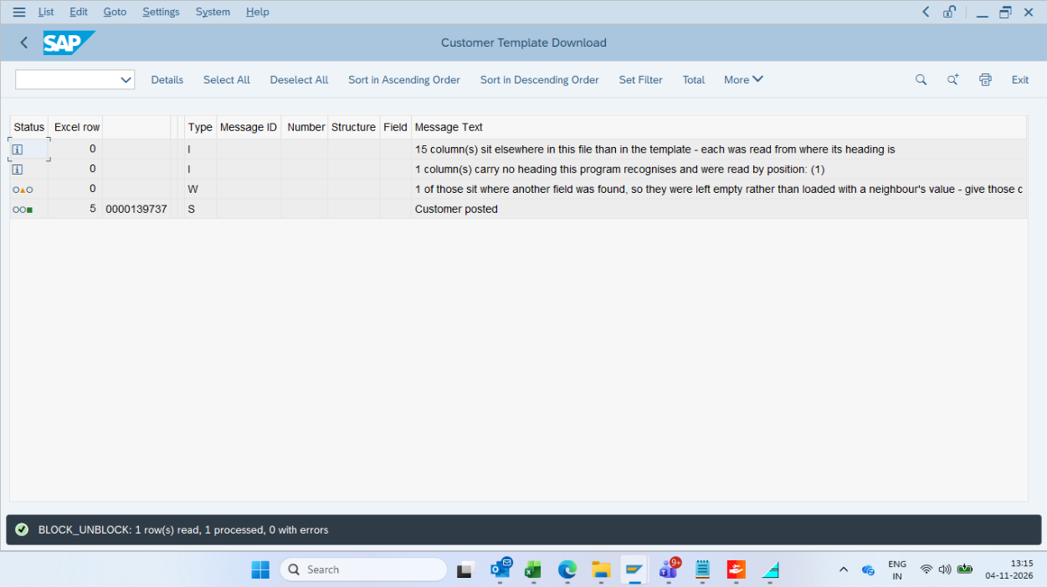
Customer Group Missing
Following customer groups not available in dropdown while uploading / downloading template for IV Invagen ( US )
- YVMI
- YVTO
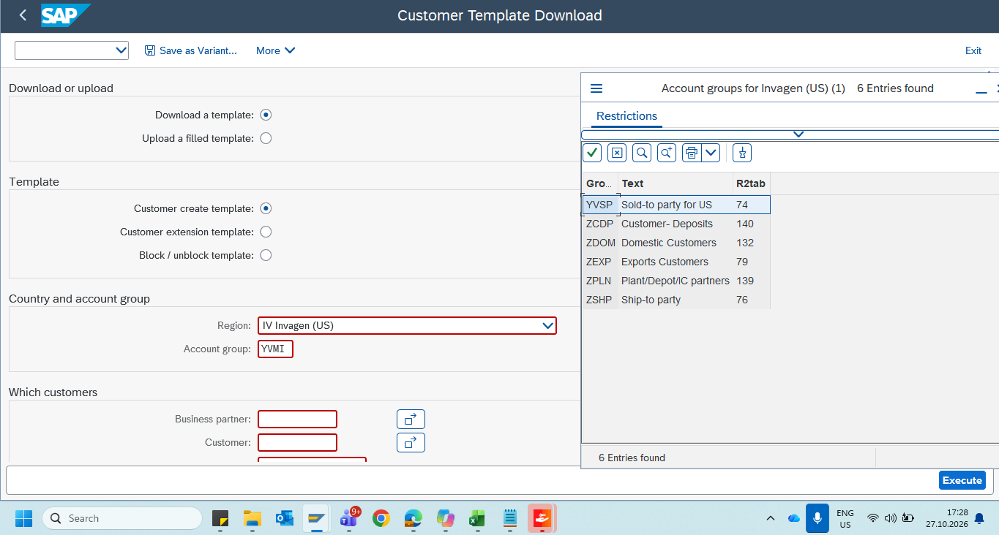

MWT Testing not done
Please note that integration testing of MWT tool to S4 HANA and vice versa is not done .

